Committed to delivering a safe environment
www.safegolf.org
for golf

Is something worrying you?
Do you need someone to talk to? Speak to your club welfare officer
kldrudge@outlook.com
07963 520665
Kristian Drudge

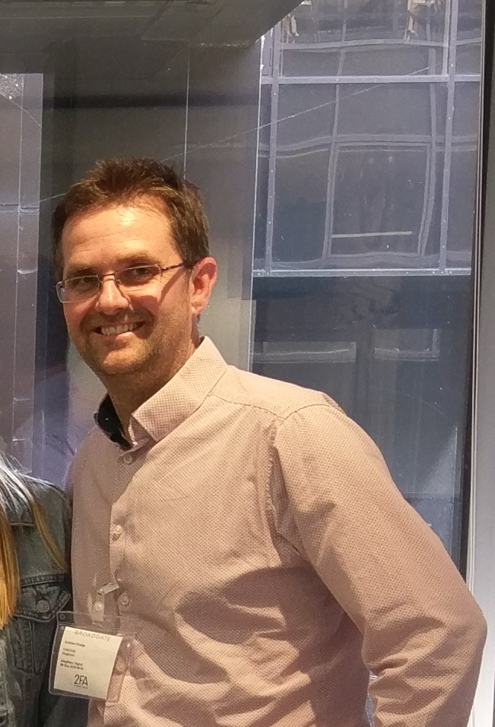

Alternatively, you can speak to someone at

ChildLine 0800 1111
ABOUT ME

Hello! Many of you know me as the Club’s
Handicap Secretary. I wish to inform you that I
now have a dual role, given I am here to support
you as your Club Welfare Officer.
If you have any concerns regarding safeguarding,
please let me know. I am here to help you and the club walk through the necessary processes to
resolve.
NSPCC 0808 800 5000
England Golf 01526 351851

Club
WELFARE
officer

